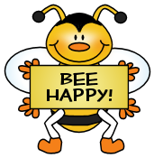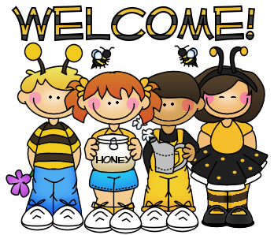

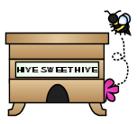

**Dates to Remember**

**Tuesday** – Wear something GRAY

**Weds.**  – Bring something GRAY

**Thursday** – Wear something RAINBOW

**Friday** – Bring something RAINBOW

**Friday** - Bring an APPLE for a fun Math activity

1st Quarter Midterms will be coming home

Wednesday, September 14tth.

Please review the information and sign and return

ONLY the half sheet of paper.

The highlighted items are the items your child could use more practice with at home.

Thursday, October 6th = Picture Day

More Info to come!

**This Week**

**We are continuing our LETTER BOOT CAMP which focuses on ONE letter a day for 26 days.**

**Letter Focus**: Tt, Uu, Vv, Ww, Xx

**Sight Words**: we, for, brown, pink

**Math Focus**: Sort and Classify

(Putting things into like groups)

Identifying SAME and DIFFERENT

We will continue recognizing and reading **COLOR** words





**Sight Words We Have Learned**

I, am, red, the, to, little, green, yellow, is, a, blue, like, orange, purple, black, white

bbf8_divider3

bbf8_divider1

**Contact Me!**

[sherry.odette@rcsc.k12.in.us](mailto:sherry.odette@rcsc.k12.in.us)

School – 866-5441

*Be sure to continue to check out our class website at*

*mrsodettes.weebly.com*

**Reminders**.

* If you haven’t signed up for REMIND 101 please do so ASAP.
* Please continue to check your child’s folder each night and initial his/her behavior chart.
* Wear tennis shoes on your child’s GYM day.

bbf8_divider3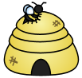

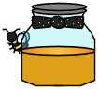

bbf8_divider4

bbf8_divider3

Your info here!

bbf8_littlebee1

bbf8_littlebee1