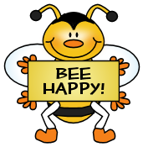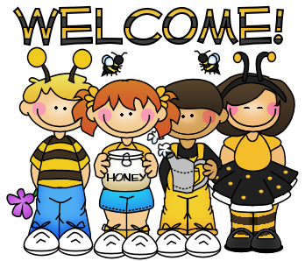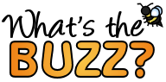

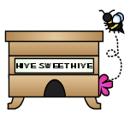

**This Week**

**We will continue with two letters each week!**

**Letter Focus**: Hh and Tt

*\*Recognizing the letter and the sound it makes*

**Sight Words**: REVIEW

**Math Focus**: Unit 3= Numbers 6-10

*\*Identify, count, and write numbers 6-10*

**Dates to Remember**

**Tuesday, October 4th** – PTA mtg at Van Elem at 6PM

**Thursday, October 6th** - Picture Day

If you’d like to send in forms before Thursday, I will hold on to them until then.

NO SCHOOL – FALL BREAK

**Friday, October 21st** and **Monday, October 24th**

**Monday, October 31st** – Fall Party

(More info to come!)





bbf8_divider3

**Reminders**

* Please continue to work with your child on READING the color words along with our other SIGHT WORDS each week.
* BOOK-IT Calendars are coming home today. Please read with your child for 10 minutes every night to earn a free personal pan pizza from Pizza Hut from October through March. ☺

**Sight Words We Have Learned**

I, am, red, the, to, little, green, yellow, is, a, blue, like, we, for, pink, black, have, my, white, purple, orange, he, with, brown

bbf8_divider1

**Contact Me!**

[sherry.odette@rcsc.k12.in.us](mailto:sherry.odette@rcsc.k12.in.us)

School – 866-5441

*Be sure to check us out at mrsodettes.weebly.com*

bbf8_divider3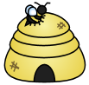

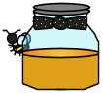

bbf8_divider4

bbf8_divider3

Your info here!

bbf8_littlebee1

bbf8_littlebee1