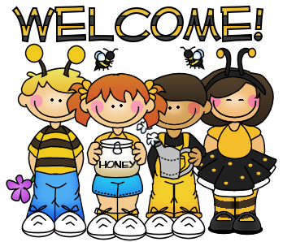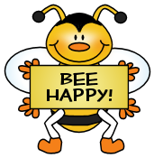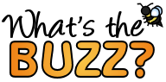

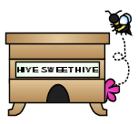



**Dates to Remember**

Thursday, September 29th – Open House 6-7 PM

Friday, September 30th – T-shirts orders and money due!

Thursday, October 6th - Picture Day

More Info to come!

THANK YOU for sending in APPLES last Friday. The kids had a ball sorting, tallying, describing, and cutting their apples so they could see the STAR inside.

The also loved eating them!

Thank you for the quick returns on the midterm forms. If you still have any questions, please do not hesitate to ask.

**This Week**

**We are finishing our LETTER BOOT CAMP on Tuesday and will begin learning two letters/sounds per week.**

**Letter Focus**: Yy, Zz, Ll

**Sight Words**: white, have, purple, my

**Math Focus**: Sort and Classify

(Putting things into like groups)

Identifying SAME and DIFFERENT

Identifying/Predicting PATTERNS

**Sight Words We Have Learned**

I, am, red, the, to, little, green, yellow, is, a, blue, like, we, for, pink, black, orange, brown

bbf8_divider3

bbf8_divider1

**Contact Me!**

[sherry.odette@rcsc.k12.in.us](mailto:sherry.odette@rcsc.k12.in.us)

School – 866-5441

*Be sure to continue to check out our class website at*

*mrsodettes.weebly.com*

**Reminders**.

* Please return the class t-shirt order form and the $9.00 together in an envelope with your child’s name on it labeled class t-shirt money.
* Our COLOR DAYS are now complete. Please continue to work with your child on READING the color words along with our other SIGHT WORDS each week.

bbf8_divider3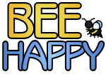



bbf8_divider4

bbf8_divider3

Your info here!

bbf8_littlebee1

bbf8_littlebee1