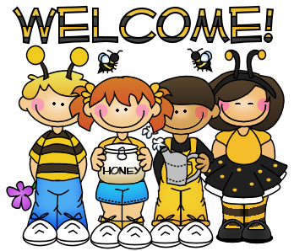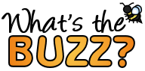

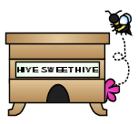

**This Week**

**We are continuing our LETTER BOOT CAMP which focuses on ONE letter a day for 26 days.**

**Letter Focus**: Kk, Ll, Mm, Nn, Oo

**Sight Words**: a, blue, is, like

**Math Focus**: Numbers 1-5

We will continue recognizing and reading **COLOR** words

**Dates to Remember**

**Tuesday** – Bring something PURPLE

**Weds.**  – Wear something PINK

**Thursday** – Bring something PINK

**Friday** – Wear something BROWN

Internet Forms are due by **Thursday, September 1st**

No School **Monday, September 5th** – Labor Day



**Sight Words We Have Learned**

I, am, red, the, to, little, green, yellow



bbf8_divider3

bbf8_divider1

**Reminders**.

* If you haven’t signed up for REMIND 101 please do so ASAP.
* Please continue to check your child’s folder each night and initial his/her behavior chart.
* Wear tennis shoes on your child’s GYM day.

**Contact Me!**

[sherry.odette@rcsc.k12.in.us](mailto:sherry.odette@rcsc.k12.in.us)

School – 866-5441

*Be sure to continue to check out our class website at*

*mrsodettes.weebly.com*

bbf8_divider3



bbf8_divider4

bbf8_divider3

Your info here!

bbf8_littlebee1

bbf8_littlebee1